

**Opening Times**

**2019**

**A local resource for parents, children, staff and professionals working with children/young people aged 0-19 as well as a developing local resource for those with Dementia and their carers**

**Information Leaflet 2019**

**www.learnerscommunitylibrary.com**

*”….I have found the library extremely valuable. It has a large array of resources, it’s like an Aladdin’s cave for my son! We have borrowed several activities to support my son’s fine motor skills, his use of pronouns, co-ordination, and listening skills. The resources are good quality, all well labelled, the sessions are well run with a clear borrowing system and lots of information on future sessions. The staff are so helpful in selecting the right activities to meet my son’s needs and the range of resources has meant we have been able to keep practicing the skills whilst having fun. There is no other service like this in our area, even his class teacher can borrow resources to support him in the classroom…”*

**Comment from parent**

*“....I like the Library because you get to borrow different toys to play with.....I borrowed some headphones to stop the noise when it gets noisy and they work....I’ve been there sometimes and I like it..My brother has disabilities and he seemed to enjoy the toys ... The black out tent was fun, me and my brother popped in and out of it......I would recommend the library far and wide...’*

**Comment from a child Yr 5**

### The library will also open on the Tuesday before the dates listed below from 5.30pm - 7.30pm for returns, browsing and borrowing as well as the Dementia Friends Drop In and new Help Point for Playlist for Life.

|  |  |  |  |
| --- | --- | --- | --- |
|  | Wed 23 January | **Browse, Borrow & Make Resources**  1pm – 5pm | **Drop In for Professional Advice**  1pm – 5pm |
| Wed 27 February |
| Wed 20 March |
| Wed 24 April |
| Wed 22 May |
| Wed 19 June |
| Wed 17 July |
| Wed 25 September |
| Wed 23 October |
| Wed 20 November |
| Wed 18 December |

**We are always open to offers from people who would like to help out in the library and would particularly welcome volunteers to make equipment for the library that more closely meets the needs of users**

**Donations to Local Giving** **or via Giving Machine**

***Printed by PRONTAPRINT***

*“I love my visits to the LCL as both a parent and SENCO.  I always go armed with a wish list request from teachers and it's like Christmas day when I return, laden with more goodies to try!  As a SENCO, I can find resources to suit almost every area of need, from those children who need some help in sitting still, to those children who might need a bit of extra help to make friends. My own children also love our visits and always come home happy and busy.*

*The staff there are very welcoming and friendly and there is a lovely play area to entertain the children while I browse and check items in and out. I would recommend it to everyone, regardless of whether or not your child has any particular difficulties.” ..parent/SENCO*

*“Your support …was a complete godsend and I would have donated anything to secure that! We are still so incredibly grateful for your wise counsel “..parent*

**Learners Community Library (LCL) relies on the commitment of volunteers from a range of professional backgrounds, as well as local students and parents.**

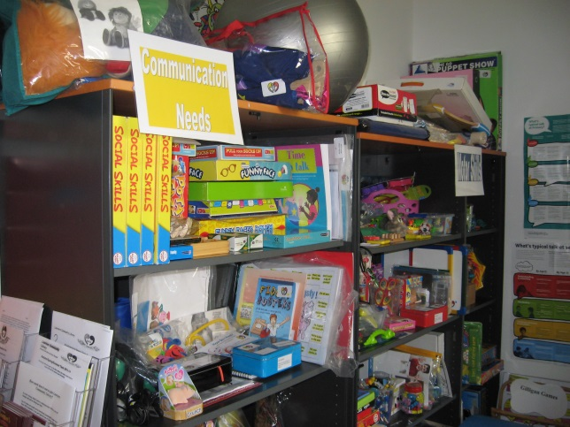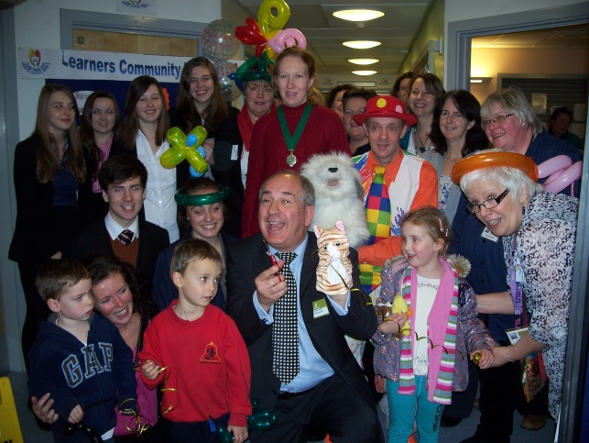

Learners Community Library

A local resource for parents, children, School/Early Yrs staff, and professionals , as well as developing for those with dementia, their carers and care home staff.

**Learners Community library (LCL)** helps all children in the local community, but particularly preschoolers, and children/young people from 0-19 who require additional advice and support to prevent/minimise future learning problems developing. It has been developed with the local community of schools (including Aspects), playgroups, professionals, children’s centres, voluntary and community organizations to improve local children’s speech, language and communication and personal, social and emotional development.

For parents, carers, children, school staff, care home and Early Years staff and professionals from the local area who subscribe to the library. Concessions if needed

**Learners Community Library**

Kitwood Unit, Herts & Essex Hospital

Bishops Stortford Herts CM23 5JH

**Phone:** Teresa Furze 07940 115943

Email: [learnerscommlib@hotmail.co.uk](mailto:learnerscommlib@hotmail.co.uk)

To make a donation, please go to:

[www.localgiving.org/charity/learnerscommunitylibrary](http://www.localgiving.org/charity/learnerscommunitylibrary)

or via Giving Street or The Giving Machine websites

Learners Community Library provides equipment, materials, support and advice in an informal setting to parents/carers, SENCOs, professionals and others working with children and young people, aged 0-19, and children themselves in the surrounding area.

The range of resources have continued to be extended from the original area of speech, language and communication (SLCN) to cover areas such as fine and gross motor coordination, behaviour management, social skills etc. There is now Dementia Friends Drop In to make better use of the resources for all as well as a new Help Point for Playlist for Life.

Library open monthly Tuesday 5.30 – 7.30 and Wednesday 1pm – 5pm (except August).

A large range of toys, books and resources professionally selected to stimulate and develop young and old minds, as well as information and advice to help all .

Drop in to a library session to browse, borrow and make resources, for advice from a range of professionals and a Dementia Friends Champion.

**How much does it cost to join Learners Community Library?**

* The first visit is free!
* There is a modest yearly subscription with no charges for borrowing individual items.
* Concessions are available for parents who need this and for newly qualified teachers.
* For further information go to our website www.learnerscommunitylibrary.com

**Membership of the library entitles you to:**

* Borrow 5 items a month from over 2,000 items available;
* Advice from LCL’s retired Educational psychologist, Autism Adviser, SPLD Advisers, Dementia Friends Champion and other professionals, as well as support from the volunteers at library sessions;
* Access software between sessions by arrangement and use of laptops
* Access Help Point for Playlist for Life;
* Photocopy/print materials and laminate them (for as long as we have sufficient funds);
* Refreshments at LCL session;
* Access an electronic copy of the resource list;
* Identify items that you’d like to be ordered;
* A car park pass for library times (for as long as the hospital continues to support this) and more.....
* And more!

Modest yearly subscription. Commitment to add or donate unused resources from own setting for everyone’s use.

At the Kitwood Unit, Herts & Essex Community Hospital, Haymeads Lane, Bishops Stortford, CM23 5JH.